**Assignment-05**

**Name.- Ghansham A. Kamble.**

**S.No.- 47.**

**Que.01-** wap to define an array of integer of size 6. Take input from user and display it in reverse order

**Ans.-**

**package Lab05;**

**import java.util.Scanner;**

**public class Question01 {**

**public static void main(String[] args) {**

**int x[] = new int[6];**

**Scanner s = new Scanner(System.in);**

**for(int i=0;i<6;i++) {**

**System.out.println("Enter a number = ");**

**x[i] = s.nextInt();**

**}**

**for(int i=0;i<6;i++) {**

**System.out.println("Array before reversing = "+x[i]);**

**}**

**for(int i=5;i>=0;i--) {**

**System.out.print(" "+x[i]);**

**}**

**}**

**}**

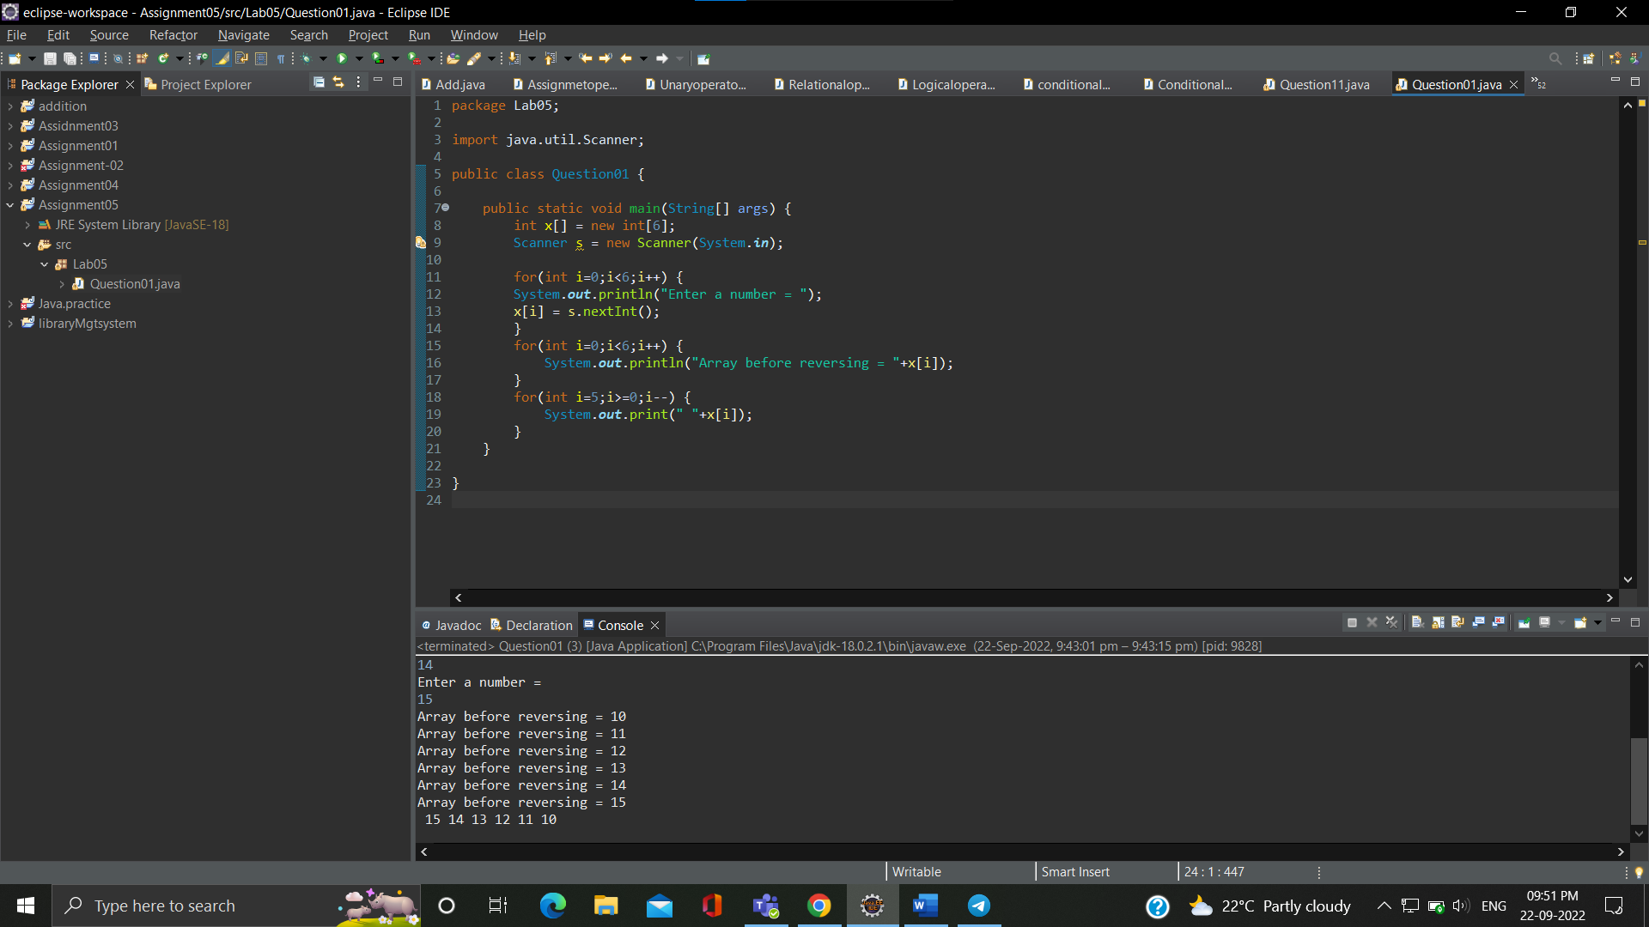

**Que.02-** wap to ask 5 names from user and check if particular name exists in array or not .

**Ans.- package Lab05;**

**import java.util.*;**

**public class Question02 {**

**public static void main(String[] args) {**

**String name[] = new String[5];**

**Scanner s = new Scanner(System.in);**

**int i;**

**for(i=0;i<5;i++) {**

**System.out.print(" Enter a name = ");**

**name[i]=s.next();**

**}**

**String n = "Abhay";**

**for(i=0;i<name.length;i++)**

**{**

**if(name[i].equals(n))**

**{**

**System.out.println(" Found ");**

**break;**

**}**

**}**

**if(i==name.length)**

**System.out.println(" not found ");**

**}**

**}**

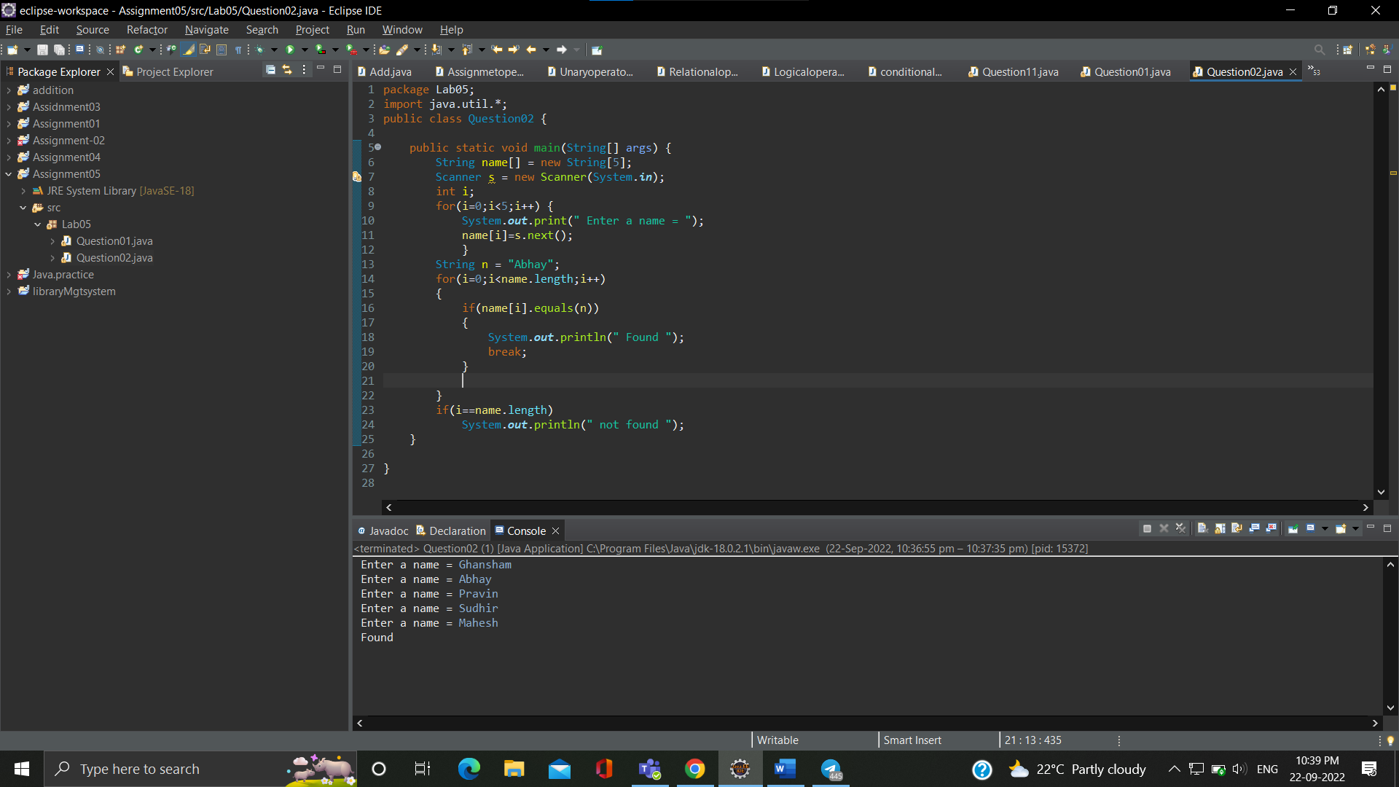

**Que.03 -**wap to define an array of integer and assign value in program and print sum of all values

**Ans.- package Lab05;**

**import java.util.*;**

**public class Question03 {**

**public static void main(String[] args) {**

**int n[] = new int[5];**

**Scanner s = new Scanner(System.in);**

**int i, sum=0;**

**for(i=0;i<5;i++) {**

**System.out.print(" Enter a number = ");**

**n[i] = s.nextInt();**

**}**

**for(i=0;i<5;i++) {**

**sum=sum+n[i];**

**}System.out.println(" SUM is = "+sum);**

**}**

**}**

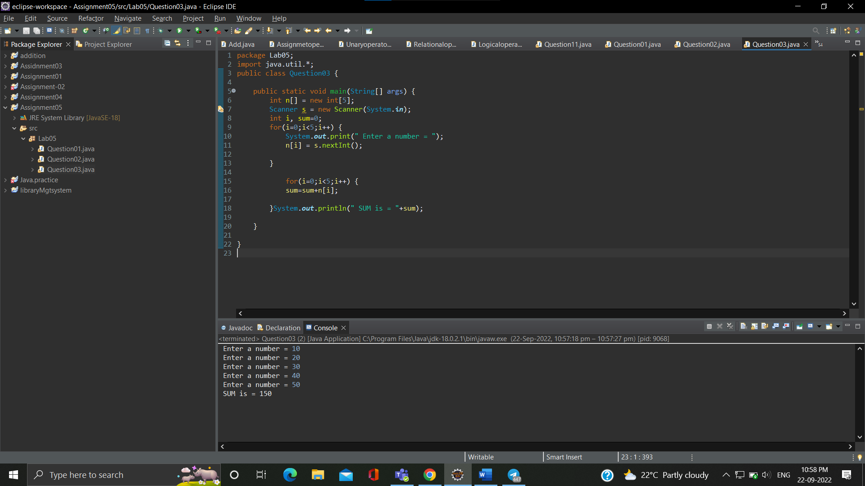

**Que.04 -**wap to print max and minimum value in given array

**Ans.-** **package Lab05;**

**public class Question04 {**

**public static void main(String[] args) {**

**int w[] = {75, 62, 24, 91, 82, 100};**

**int max=w[0];**

**for(int i=1;i<w.length;i++)**

**{**

**if(max<w[i])**

**max= w[i];**

**} System.*out*.println("Maximum number is = "+max);**

**}**

**}**

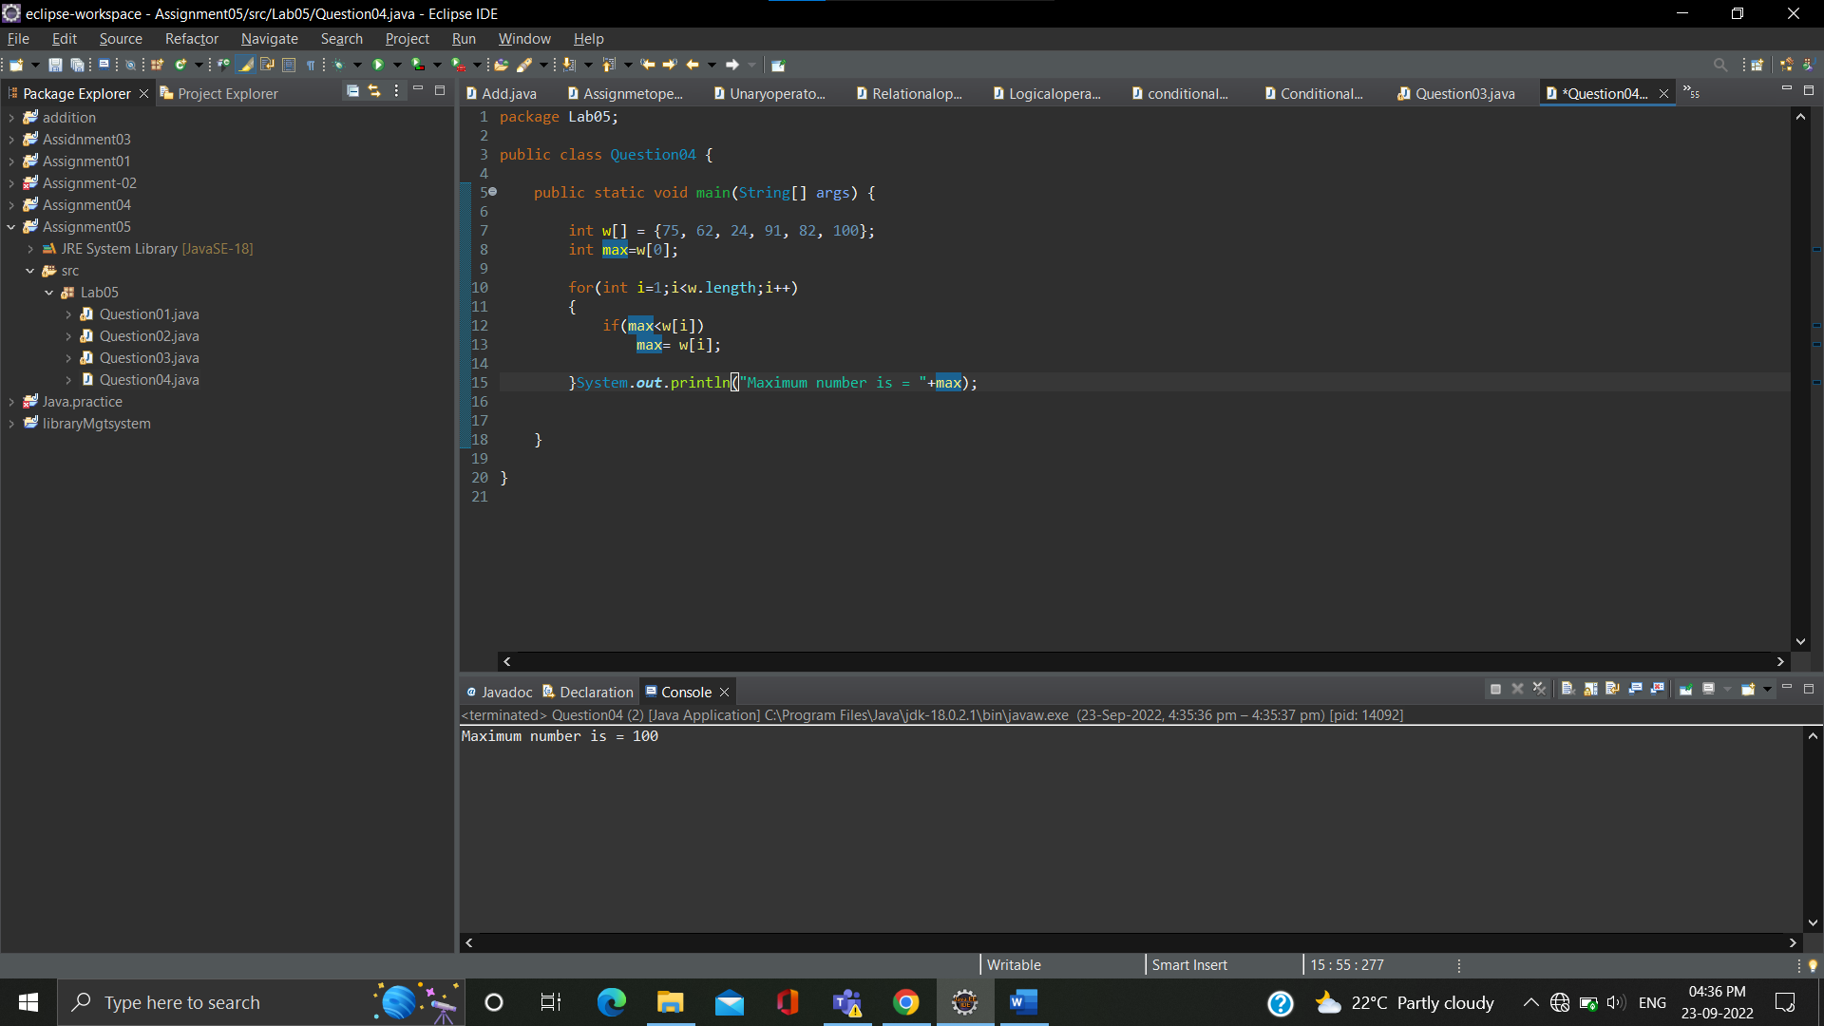

**Que.05-** wap to find and print even numbers in given array

**Ans.-** **package Lab05;**

**public class Question05 {**

**public static void main(String[] args) {**

**int x[]= {11,12,13,14,15,16,17,18,19,20};**

**for(int i=0;i<x.length;i++)**

**{**

**if(x[i]%2==0)**

**{**

**System.*out*.println("even number is = "+x[i]);**

**}**

**}**

**}**

**}**

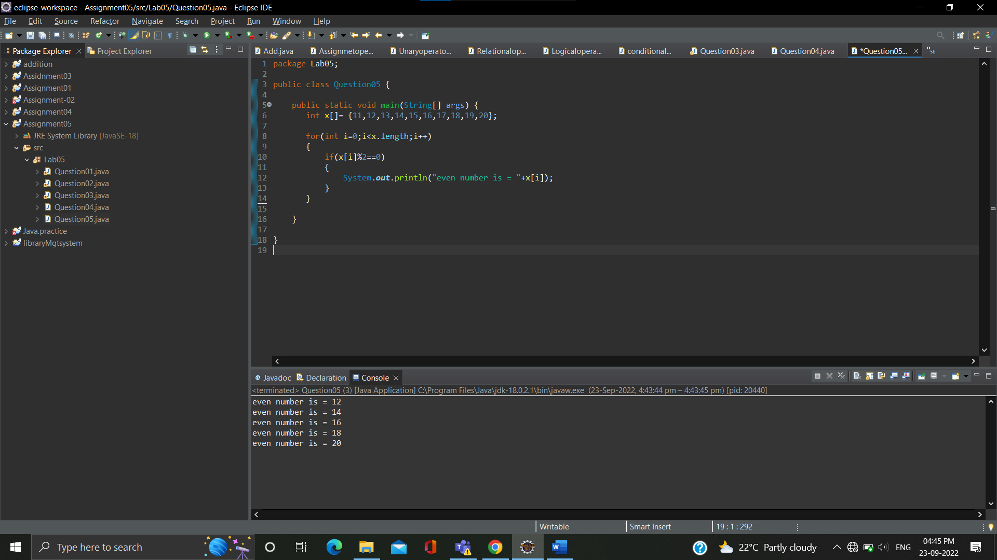

**Que.06-** wap to find and print prime numbers in given array

**Ans.-**